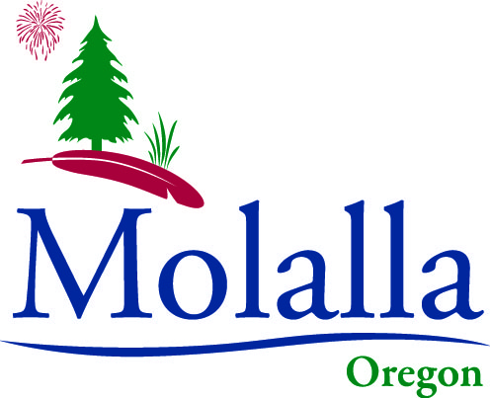

JOB DESCRIPTION CITY OF MOLALLA

Job Title: Public Works Laborer I

FLSA Status: Non-Exempt
Department: Public Works
Union Representation: Represented

Class Summary
Works under the general guidance and direction of the Public Works Foreman. Some work such as vehicle, sewer, storm and street sign work is done somewhat independently. Some training and direction provided by Laborer III’s.
Duties and Responsibilities
(An employee in this classification may perform any of the following duties; however, these examples do not include all the specific tasks that an employee may be expected to perform)
- Performs a variety of tasks in the Public Works Department.
- Assists with the installation and repair of water lines, sewer lines and storm sewer lines.
- Installs road signs.
- Fill and patch potholes.
- Paint traffic markings.
- Performs other street maintenance duties.
- Occasionally operates dump truck and small equipment.
- Reads water meters monthly as requested.
- Works on city parks as needed.
- Services, washes and cleans the inside of city vehicles.
- Performs city building and grounds maintenance as needed.

The above description covers the most significant duties performed but does not exclude other occasional work assignments not mentioned.

Qualifications
- High School diploma or equivalent.
- Valid Oregon commercial driver’s license.
- Experience with backhoe preferable.

Work Environment
Undesirable working conditions. Exposed to noise, dust, sewage, hear, rain and foul weather.

